NSI Connection Service Protocol v0.9

Status of This Document

This document provides information to the Grid community on the NSI Connection Service that operates on the interface between a requesting software agent and the provider software agent. It describes the protocol, architecture and associated processes and environment in which software agents interact to deliver the Connection Service. Distribution is unlimited.

Copyright Notice

Copyright © Open Grid Forum (2008-2010). All Rights Reserved.

Trademark

OGSA is a registered trademark and service mark of the Open Grid Forum.

Abstract

This document describes the Connection Service Protocol for the Network Service Interface (NSI). The Connection Service is used to manage connection oriented circuits that transit network providers. The Network Service Interface (NSI) is defined to be the set of protocols and parameters that are used between a software agent requesting a network service and the software agent providing that Network Service. The Connection Service is intended to operate within the Network Service Framework (NSF, GFD.173).

Contents
1. Context and Overview 2
2. Connection Service architecture 2
3. Connection Service lifecycle 3
3.1 Connection Service primitives 3
3.2 Connection Service state machine 5
3.3 Requesting a reservation 7
3.4 Provisioning a Connection 7
3.5 Releasing the provisioning state 8
3.6 Terminating a connection request 8
3.7 Forced end 8
3.8 Querying a Connection 8
4. Connection Service primitives and attributes 9
4.1 NSI common attributes 9
4.2 Service common attributes 9
4.3 Connection Service primitives 10
4.4 Attributes for requesting a reservation 10
4.5 Attributes for terminating a reservation 13
4.6 Attributes for requesting provisioning 13
4.7 Attributes for releasing provisioning 14
4.8 Attributes of a Query 15
5. Connections: Transport and Service planes 17
6. STPs and path objects 18
6.1 STP syntax 18
6.2 Under-specified STPs 18
6.3 Path Object 18
6.4 Path object example – NSA chain 19
6.5 Path object example – NSA tree 20
7. Inter-domain pathfinding 20
8. Authentication and Authorization 21
8.1 Security Requirements 21
8.2 Message Security 21
8.3 Authorization 21
9. Service Definitions for Connection Services 21
10. Failures and exceptions 25
10.1 Service plane failures 25
10.2 Transport plane failures 25
11. Contributors 26
12. Glossary 26
13. Intellectual Property Statement 28
14. Disclaimer 28
15. Full Copyright Notice 28
16. References 29
17. Outstanding issues 29

Context and Overview
The NSI protocol is defined by a suite of documents. This recommendation describes the NSI Connection Service Protocol and should be read in conjunction with the NSI Network Services Framework (NSF, GFD.173).

The Network Service Framework (NSF) defines several key architectural elements: a Network, a Network Service, a Network Service Agent (NSA), a Network Service Interface (NSI), and a NSI Protocol. These elements exist in a notional Network Service Plane. The framework describes an environment within which network resources are treated as explicitly manageable objects. Within the framework, these network resources can be selected, allocated, interrogated, and manipulated by software agents on behalf of requesting users.

Network resources and capabilities are presented to the consumer through a set of ‘Network Services’. The Network Services Framework presents a unified model for interacting with these services. Network Services include the ability to create connections, to share topology information, and to do other services needed by a set of federated NSAs.

This document defines a Connection Service protocol to support the reservation, creation, management and removal of Connections.

Where Capitalized words are used in this document, these have a formal definition; see the glossary for details.

Connection Service architecture
The Connection Service is one of the services supported by the Network Service Framework (NSF). The connection service communicates using messaging between Requester Agent (RA) and Provider Agent (PA) state machine pairs; this RA/PA relationship conforms to the usage defined in the NSF. Figure 1 shows an example of the use of Connection Service and RA/PA pairs.

The NSI messages exchanged between RA and PA (red lines) and the associated RA and PA state machine make up the NSI CS protocol definition. The NSA functionality and associated internal NSA messages, while mentioned in this document, do not for a normative part of the NSI CS protocol.

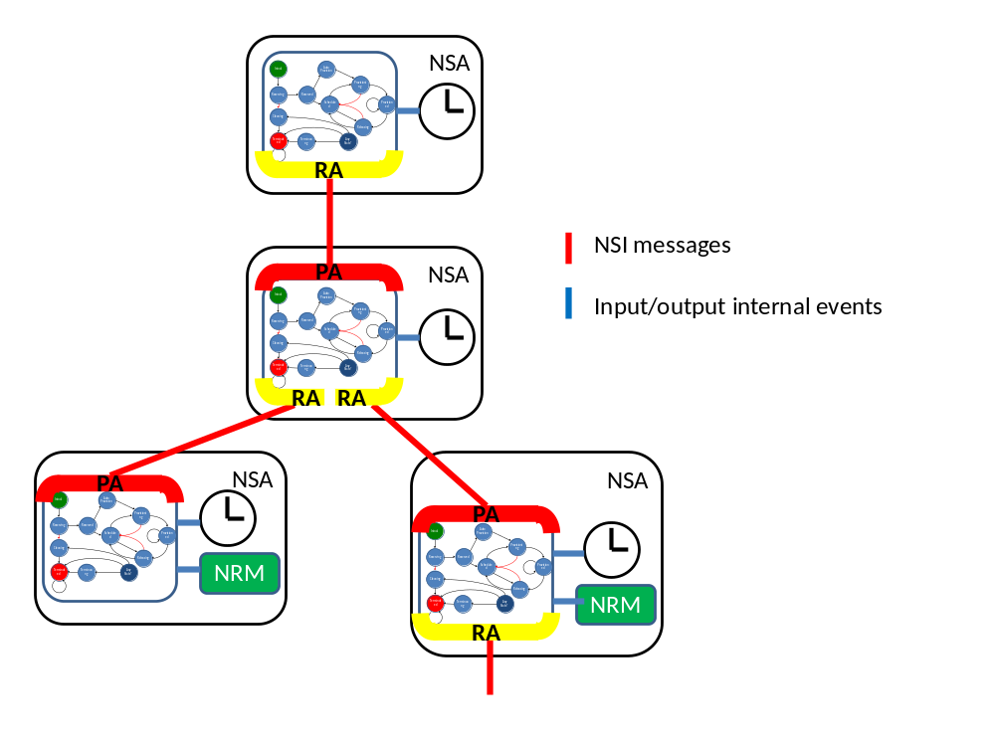
Figure 1: Example of NSA roles

The NSA may take on a parent or child role in relation to other NSAs, the requester is parent to one or more child NSAs.

The Network Resource Manager (NRM) is the function that performs the local control of the network resources. Typically this might be a local network management system.

The Connection service’s behavior can change depending on the existence of an NRM and the existence of a parent or children NSAs. In general, 3 combinations of RA, PA and NRM are identified:
- An NSA with the originating RA in the hierarchy is referred to as a CS originator
- An NSA with a PA and one or more RAs is referred to as a CS aggregation
- An NSA with a PA and an NRM only is referred to as a CS ultimate provider
- An NSA with a PA and an NRM and one or more RAs is referred to as a CS aggregation and ultimate provider

Connection Service lifecycle

Connection Service primitives
The Connection Service (CS) protocol is a message based command-response protocol that operates between an RA and a PA.

The NSI CS protocol defines a set of six primitives that provide the control necessary to manage Connections. Each has 3 possible variants:
- Request – The RA sends the request to the PA, for example reserveRequest.
- Confirm - A PA sends this positive operation response message (such as reserveConfirm) to the Requester NSA that issued the original request message (reserveRequest).
- Failed - A Provider NSA sends this negative operation response message (such as reserveFailed) to the Requester NSA that issued the original request message (reserveRequest).

The six primitives used by the RA to manage a PA are described in the following table

Primitive | Description
reservationRequest (Confirm/Failed) | the RA requests the PA for reservation of network resources for a connection between two STP’s constrained by certain service parameters
provisionRequest (Confirm/Failed) | the RA requests the PA to provision a reservation (associated with a previous reservation message)
releaseProvisionRequest (Confirm/Failed) | the RA request for the PA to de-provision resources without removing the reservation
terminateReservationRequest (Confirm/Failed) | the RA request for the PA to release the provisioned resources and terminate the reservation
forcedEndRequest | This is reported by the PA to the RA to notify that the PA has forced an termination of the reservation
queryRequest | mechanism for either RA or PA to query the other NSA for a set of connection service instances between the RA-PA pair. This message can be used as a status polling mechanism
Table 1: list of primitives

The following figure shows to examples of how message primitives are used to first reserve and then provision a connection. Two modes of provisioning are supported: Manual and Automatic.
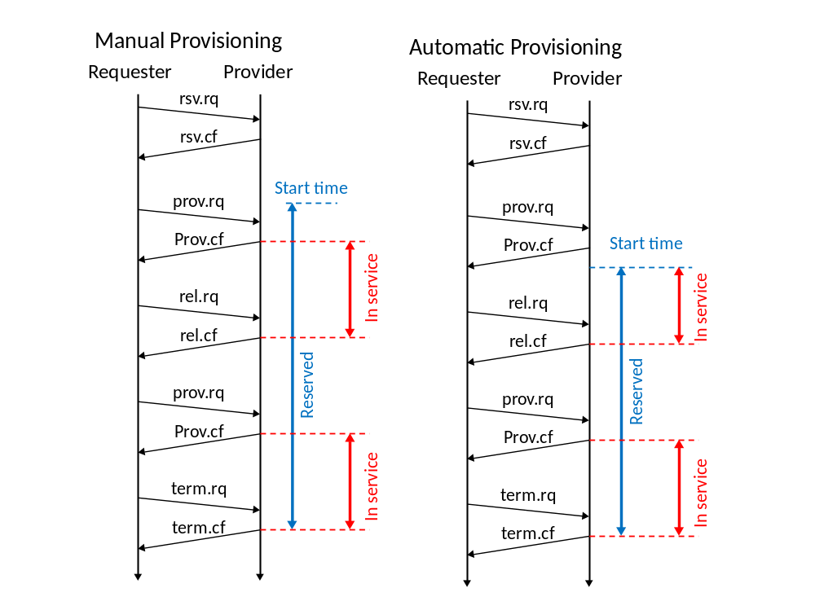
Figure 2: Connection Service lifecycle
For brevity in this diagram and the state machine diagram, the NSI messages are abbreviated as follows:
rsv reservation
prov provision
rel release
term terminate
fcd_end forced end
rq request
cf confirm
fl failed

These connection service message primitives are used to initiate, manage and remove a connection (the connection life cycle). A common state machine describes the state changes and their relationship to messages. The primitives, timing events and NRM responses from inputs and outputs to the state machine. The connection state can be any of the following:

State | Description
Initial | nothing exist yet, the RA and PA are waiting the user initiation
Reserving | a reservationRequest has been sent and the PA is attempting to make a reservation
Reserved | the reservationRequest has succeeded and a reservation has been created. Note that here the provisioning state is either unprovisioned or indeterminate
AutoProvision | A reservation is present and a provisionRequest has been received, waiting for the startTime to arrive so that automatic provisioning can be initiated
Scheduled | the reservation is active (after the startTime), however either a provisionRequest has not been received yet, or the provisioning has been released
Provisioning | both a provisionRequest has been sent and startTime has arrived, so provisioning is ongoing
Provisioned | the Connection has been correctly provisioned
Releasing | a releaseRequest has been sent and a release is ongoing
Cleaning | a reservationFailed message has been received so the reservation is being cleared
Terminating | a terminateRequest message has been sent and the reservation and if necessary the provisioning are being removed
Terminated | nothing exists any longer, a terminate request has been successful
Table 2: list of states

Connection Service state machine
The Connection Service state machine is shown in . This is a generic state machine which incorporates all of the possible operational modes: originator, aggregation and ultimate provider.

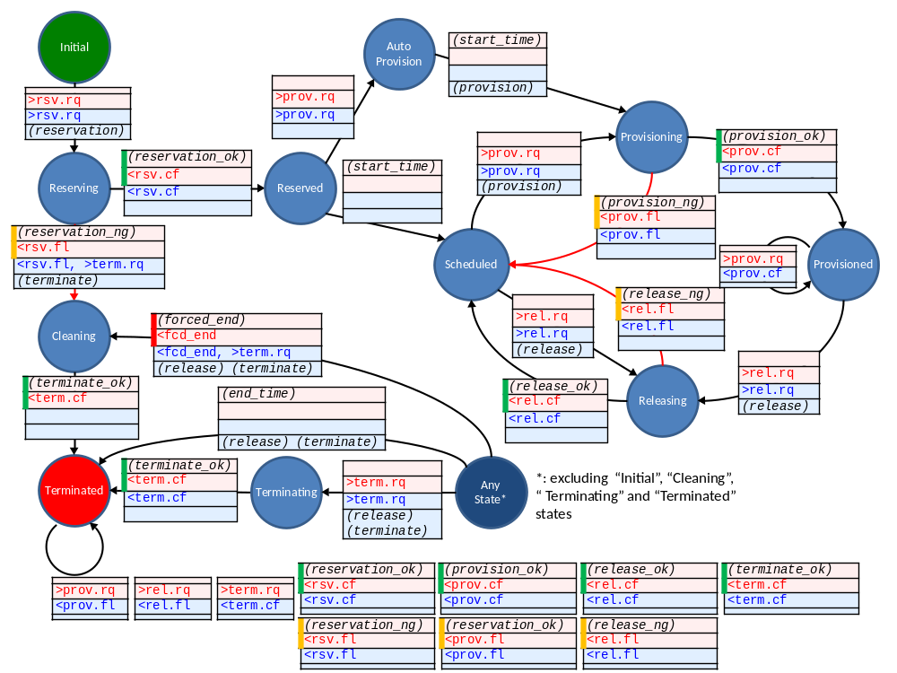
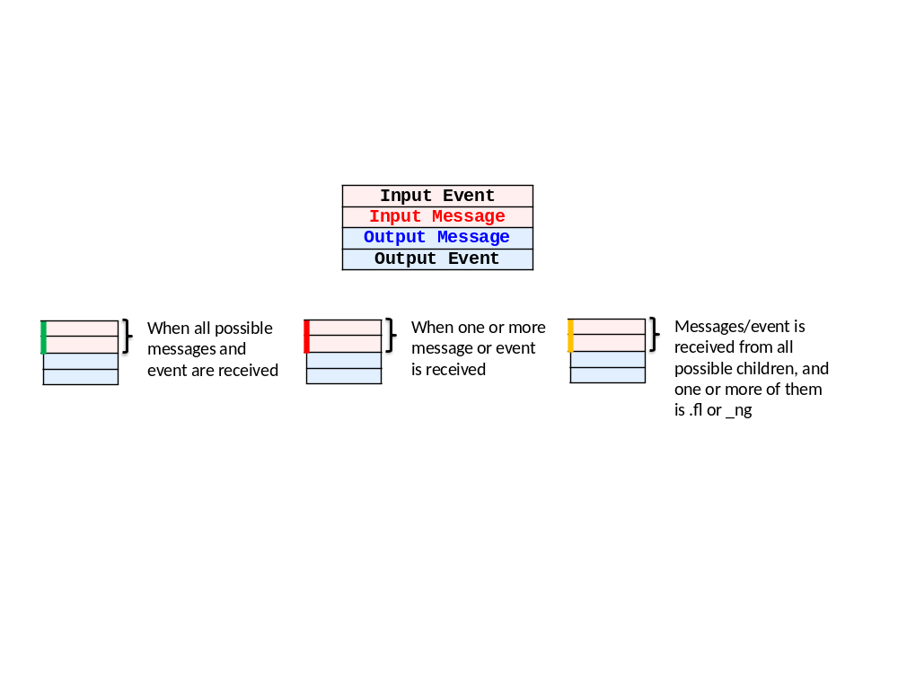
Figure 3: NSI connection service state machine

The text boxes show the messages associated with transitions between states. These are color coded as follows:
black: an internal event – either a timer or result of an operation within the NSI protocol.
red : an incoming NSI message – this may be from either a parent or child NSA
blue: an output event which is a NSI message – this may go to either a parent or a child NSA

NSI messages have an associated direction; upstream messages are forwarded the by a PA to an RA, downstream messages are sent from a RA to a PA. These directions are indicated with the use of the following symbol prefixes:
>: Downstream input/output
<: Upstream input/output

The following internal messages are possible. Note that these are a non-normative part of the NSI specification.

SM -> NRM
reservation: reserve the requested resources on the local NRM.
provision: provisioning of resources within local NRM
release: release of resources within the local NRM
terminate: terminate of a reservation within local NRM

NRM -> SM (reply)
*_ok: the requested action in the local NRM was completed successfully..
*_ng: the requested action failed in local NRM.

NRM -> SM (asynchronous event)
forced_end: resources allocated to the schedule were (administratively) released by the local NRM

Timer -> SM
start_time: start time of the reservation has been reached
end_time: end time of the reservation has been reached

Requesting a reservation
A reservationRequest is sent by the RA to the PA to initiate the lifecycle of the Connection. The state then transitions from Initial state to Reserving state in both the RA and the PA. In the Reserving state the PA performs both path computation and resource reservation. If the Reserving process completes successfully (also in all child NSAs) a reservationConfirm message is sent to the RA and the Connection moves into the Reserved state.

If the reservation process fails locally or in any of the child NSAs (due for example to the failure of path computation), then the PA issues a reservationFailed message to the RA, and the Connection moves to the Cleaning state in both RA and PA and issues a terminateRequest to all child NSAs and a terminate instruction to the local NRM..

Once the local NSA responds with a terminate_ok message and any child NSAs come back with a terminateConfirm message, the state machine is terminated and the reservation no longer exists.

Provisioning a Connection
When the Connection is in the Reserved state the RA can send a provisionRequest message. This request will be treated in two possible ways depending on the arrival of the request in relation to the startTime specified in the reservationRequest message:
- Manual Start: Where the startTime has already passed (according to the PA local timer), receipt of the provisionRequest message results in the Connection state moving to Scheduled.
- Auto Start: Were the startTime has not yet arrived (according to the PA local timer), the Connection moves to the AutoProvision state and waits until the startTime is reached. The Connection state then moves to Provisioning without further action by the RA at the commencement of the startTime.

When the local NRM or child NSAs indicate that the provisioning has been completed, the PA issues a provisionConfirm message to the RA and the Connection moves to the Provisioned state. If the provisioning fails, a provisionFail message is issued by the PA to the RA. No further action is taken – the reservation moves to Scheduled state.

Connection lifecycle remains in the Scheduled state until a) a provision Request is re-tried, b) a Terminate request is received, or the reservation expires (end_time is reached) and is automatically terminated by the PA.

A provisionRequest for a Connection already Provisioned is allowed and does not affect the service instance. A provisionConfirmed is returned. This action is specified in order to easily recover and synchronize connections that may have otherwise had piecewise interruptions to children.

Releasing the provisioning state
When a Connection is in the Provisioned state, the RA can send a releaseProvisionRequest. When a PA receives this request the Connection moves from the Provisioned state to the Releasing state and the local NRM and child NSAs are notified to de-provision the data plane resources associated with this connection. De-provision means that the data plane is no longer operational, but the resources remain reserved for the Connection in question. When the local NRM and all child NSAs indicate that the de-provisioning has been completed, the PA issues a releaseConfirm to the RA and the Connection moves to the Scheduled state.

If the local NRM or any child NSA fails to release completely, a releaseFailed message is issued to the RA and the connection moves to Scheduled state.

A releaseProvisionedRequest for a connection already released is allowed but no action is performed.

Terminating a connection request
In any state the RA may send a terminateReservationRequest message to the PA. The Connection will then immediately move to the terminating state, initiate a removal of the local reservation and forward the terminateReservation to all child NSAs. Once the reservation has been removed (and if necessary the provisioning cancelled), both locally and on all child NSAs, the Connection moves to the Terminated state and the terminateConfirm message is sent to the RA.

Forced end
The PA may force the end of a reservation. In this case a forcedEndRequest message is sent upstream and the state changes to Cleaning state. In the cleaning state the RA removes the reservation.

Querying a Connection
The RA may send a query to the PA to find the state of a Connection. The PA returns the information about all service attributes associated with the connection as resolved in satisfying the reservation request. *** needs explanation of how to use filter**

Connection Service primitives and attributes

NSI common attributes
This section describes the attributes which are common to all NSI messages. *** move this section to NSF document?***

NSI and Connection Service versions
The protocol allows new versions of the NSI framework and the connection service to be released in future. This is achieved with the use of version numbering. An NSIversion and a connectionServiceVersion attribute may be used; alternatively, web service implementations may use namespaces for this purpose.

NSI common attributes
Message attributes includes the attributes that are common to all NSI messages regardless of the service type.

The NSI framework is a platform that ensures independence between services and allows one service to be upgraded to a new version without affecting other services. This is achieved with the use of service version numbering.

requesterNSA
This message attribute identifies the requester NSA sending a request or receiving a response to a request or receiving a notification. This is of type URI.

providerNSA
This message attribute identifies the provider NSA receiving a request or sending a response to a request or sending a notification. This is of type URI.

sessionSecurityAttr - Security attribute associated with the NSI connection services session between a Requester/Provider NSA pair. This attribute is an opaque element that contains information that may be used to authenticate the requesterNSA and authorize its request. This attribute is a tuple of attributeName, attributeValue, both of type string

transactionId
A transaction identifier provided by the requesting NSA used to correlate to an asynchronous response from the responder. ** type integer?**

replyTo
** I’m not sure how to describe why this is needed**

Service common attributes
Service attributes includes all attributes that are common to a particular service. In the case of the Connection Service, this includes the Connection identifier, the relevant service primitive and a transaction identifier.

connectionId
The Requester NSA assigns a connectionId for each Connection. This value must be unique within the context of the Requester NSA but does not need to be globally unique. The connectionId attribute is of type string. It is recommended that a Universally Unique Identifier (UUID) URN as per IETF RFC 4122 be used as a globally unique value.

globalReservationId
The globalReservationId is an optional reservation identifier that is common for the end-to-end connection. It is globally unique and can be used to correlate individual related service reservations through the network. The globalReservationId is of type Universally Unique Identifier (UUID) URN as per IETF RFC 4122 be used as a globally unique value.

description
The description attribute is optional description for the service reservation. This attribute is type string.

Connection Service primitives
The Connection Service primitives are described in detail in this section. This message attribute identifies a connection service functional primitive. The allowed Connection Service Primitives are shown in the following figure:

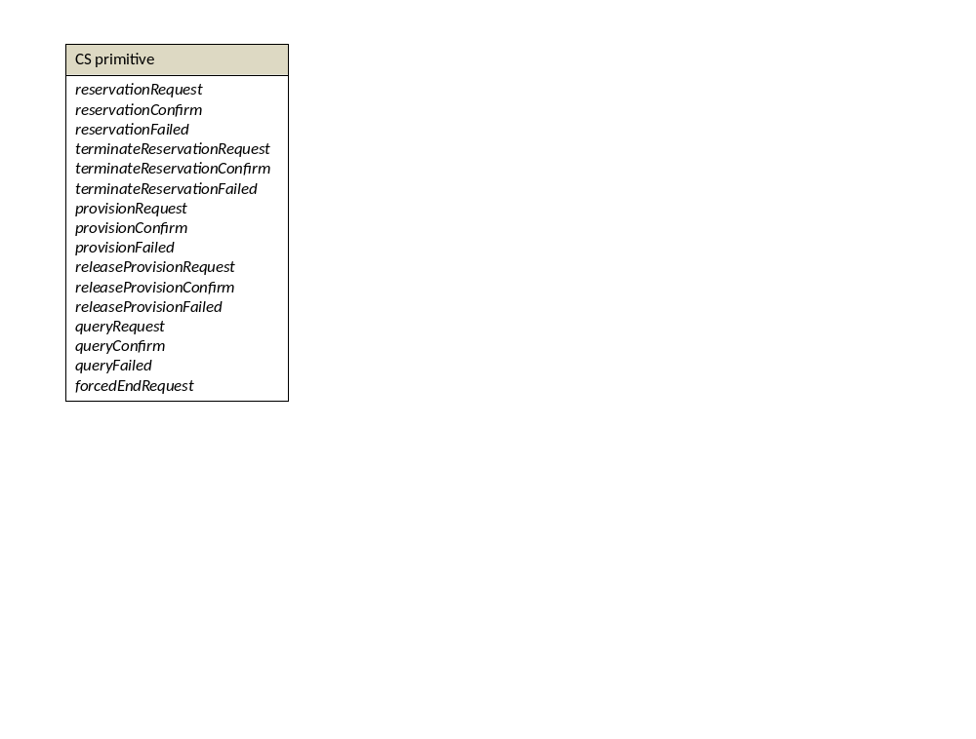
Figure 4: CS primitives

Attributes for requesting a reservation

A Connection may be reserved with the reservationRequest message. The attributes of this primitive provide information necessary to create a reservation. This includes the start and end points of the Connection, the start and end time of the reservation, and service parameters which describe the client framing and end-to-end performance of the Connection.

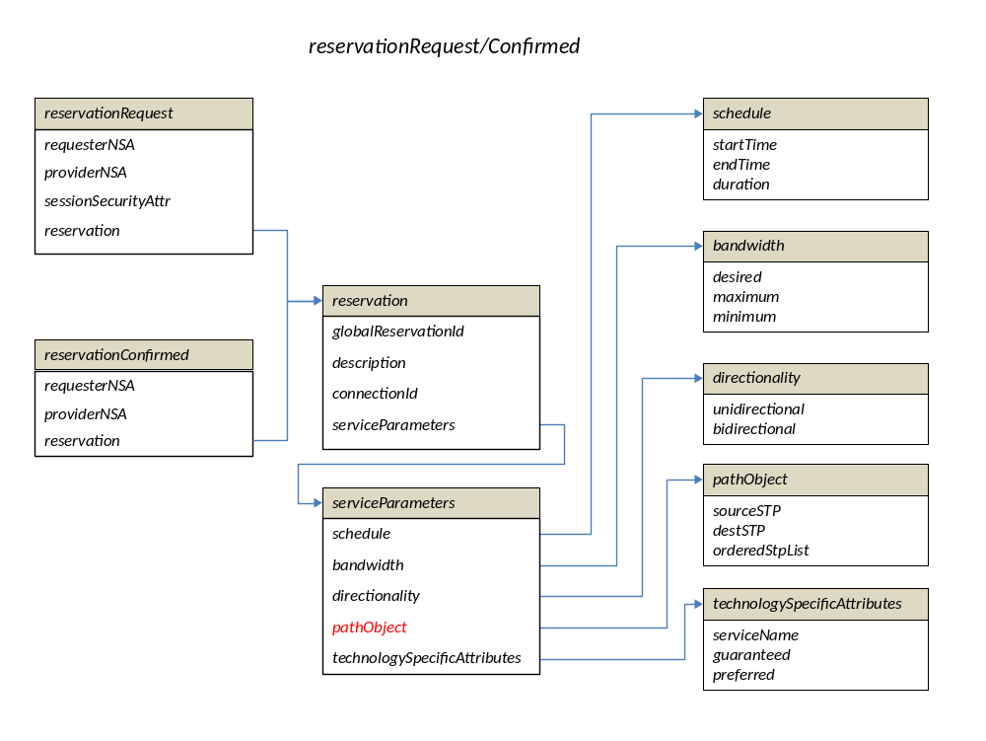
Figure 5: reservationRequest/Confirmed

The Connection Service has an associated Service Definition (SD). The Service Definition formally describes the service level that a user can request. This lists the attributes needed to define the performance of the circuit as experienced by the user. These are not defined in the WSDL, but are included in the TechnologySpecificAttributes.

Reservation is a grouping of the following attributes:
globalReservationId
description
connectionId
serviceParameters

serviceParameters is a grouping of the following attributes:

schedule - time parameters specifying the life of the service.
startTime - Reservation start time, type XML dateTime [29]
endTime - Reservation end time, type XML dateTime [29]
duration - Reservation duration, type XML duration [reference]

bandwidth - bandwidth of the service.
desired - the desired bandwidth Mb/s being requested, type integer
minimum - the minimum bandwidth in Mb/s acceptable by the request, type integer
maximum - the maximum bandwidth in Mb/s acceptable by the request, type integer
directionality - directionality of the service: enumerated type: bidirectional or unidirectional

pathObject - the source and destination endpoints of the service.
sourceSTP - Source STP of the service and techSpecAttrs, type STPtype
destSTP - Destination STP of the service and techSpecAttrs, type STPtype
orderedStpList - ordered list of STP from source to destination excluding the sourceSTP to destSTP, type OrderedStpListType

STPtype is described using a tuple:
networkId - An abstract reference to a network containing the STP. Type tbc
localId - A locally unique identifier for the STP within the target network. Type tbc

OrderedStpListType
This is a simple ordered list if list of Service Termination Point (STP). List order is determined by the integer order attribute in the OrderedServiceTerminationPointType.
orderedStpList - A list of STP ordered 0..n by their integer order attribute.

TechnologySpecificAttributes - Technology specific attributes relating to the service
guaranteed - Attributes that MUST be met by the service. name:value of type string
preferred - Attributes that MAY be met by the service. name:value of type string

In the case of a successful completion of the reservation request the reservationConfirm response is returned with the following attributes:
requesterNSA
providerNSA
reservation

In the case of a failed completion of the reservation request the reservationFailed response is returned with the following attributes: requesterNSA, providerNSA, globalReservationId, connectionId, connectionState and serviceException.

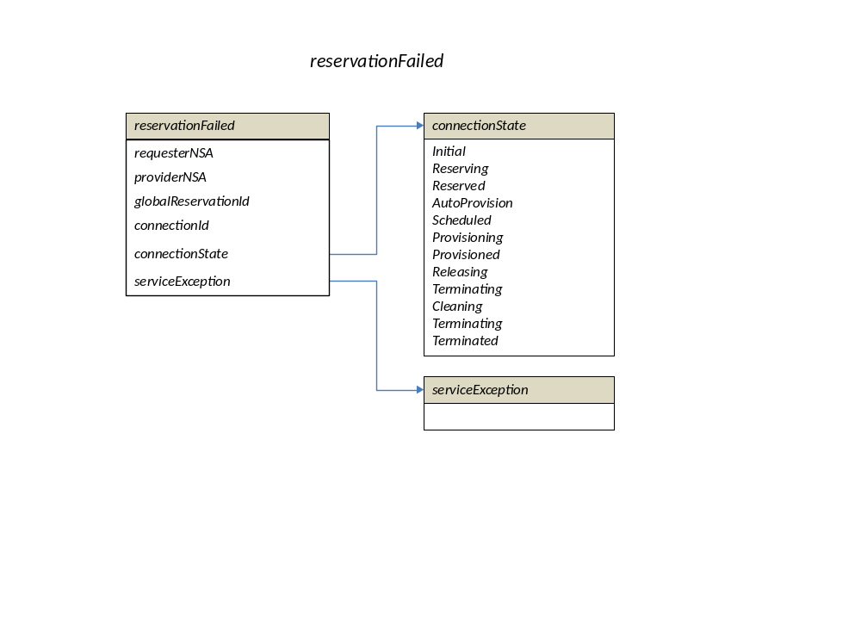
Figure 6: reservationFailed

The connectionState attribute contains the current state of the Connection (as per the state machine) and is of type enumerated list of states.

The serviceException attribute has the following structure: messageId:text:AttributeName:Attributevariable, all of type string.

Attributes for terminating a reservation

A reservation can be removed by sending the terminateReservationRequest message primitive with the following attributes: requesterNSA, providerNSA, sessionSecurityAttr, connectionId

In the case of a successful completion of the reservation request the terminateReservationConfirmed response is returned with the following attributes: requesterNSA, providerNSA, globalReservationId, connectionId, connectionState

In the case of a failed completion of the terminate request the terminateReservationFailed response is returned with the following attributes: requesterNSA, providerNSA, globalReservationId, connectionId, connectionState, serviceException

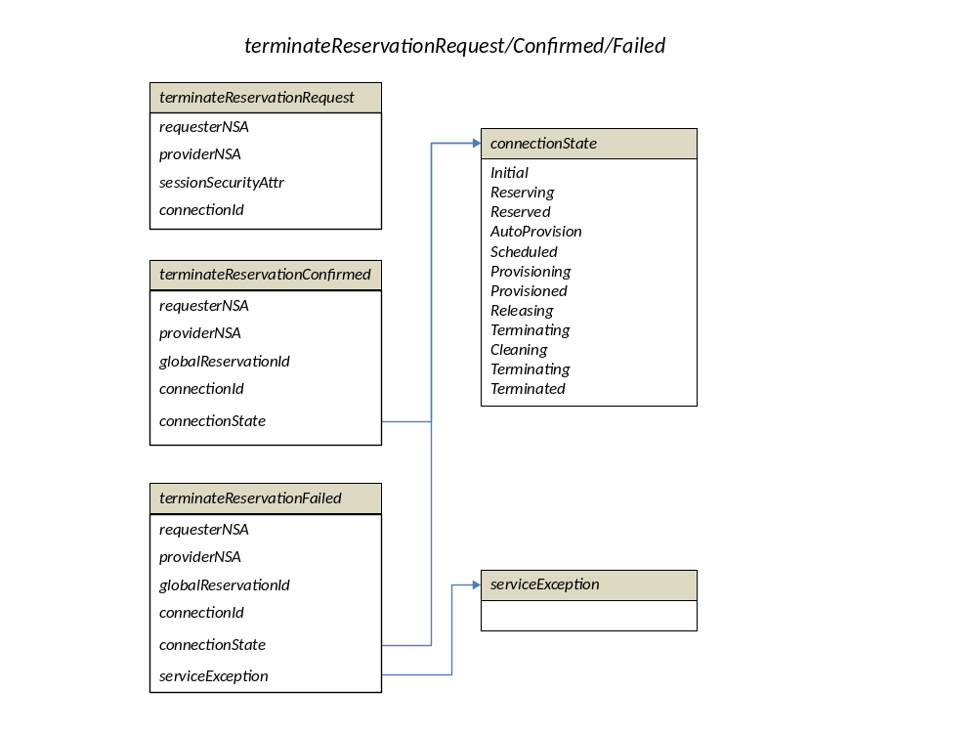
Figure 7: terminateReservation

Attributes for requesting provisioning
A reservation can be provisioned by sending the provisionRequest message primitive with the following attributes: requesterNSA, providerNSA, sessionSecurityAttr, connectionId

In the case of a successful completion of the provision request the provisionConfirm response is returned with the following attributes: requesterNSA, providerNSA, globalReservationId, connectionId, connectionState

In the case of a failed completion of the provision request the provisionFailed response is returned with the following attributes: requesterNSA, providerNSA, globalReservationId, connectionId, connectionState, serviceException

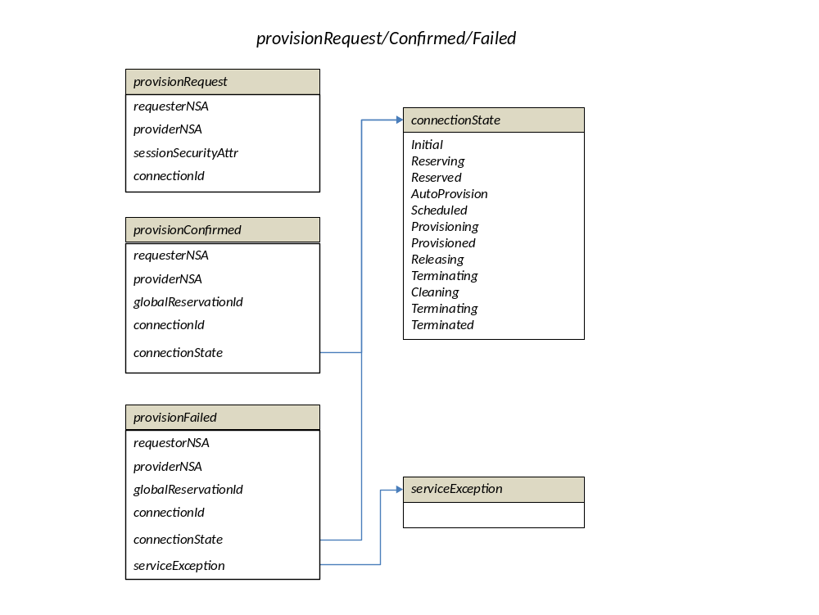
Figure 8: provision

Attributes for releasing provisioning
A reservation can be de-provisioned by sending the releaseProvisionRequest message primitive with the following attributes: requesterNSA, providerNSA, sessionSecurityAttr, connectionId

In the case of a failed completion of the de-provisioned request the releaseProvisionFailed response is returned with the following attributes: requesterNSA, providerNSA, globalReservationId, connectionId, connectionState, serviceException

In the case of a successful completion of the de-provisioned request the releaseProvisionConfirm response is returned with the following attributes: requesterNSA, providerNSA, globalReservationId, connectionId, connectionState
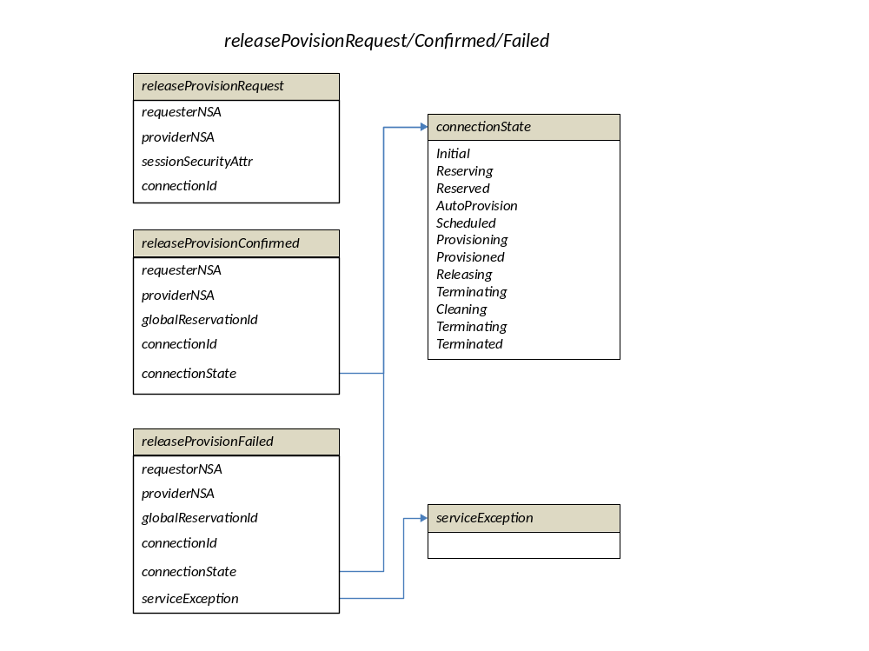

Figure 9: releaseProvision

Attributes of a Query
The query primitive allows the Requester NSA to query the Provider NSA. Supports querying based on connectionId, globalReservationId, or connectionState (criteria up for discussion). Filter items specified are OR'ed to build the match criteria. If no criteria are specified then all reservations associated with the requesting NSA are returned.

A query can be requested sending the queryRequest message primitive with the following attributes: requesterNSA, providerNSA, sessionSecurityAttr, queryFilter. The queryFilter contains 3 attributes: connectionId, globalReservationId, connectionState

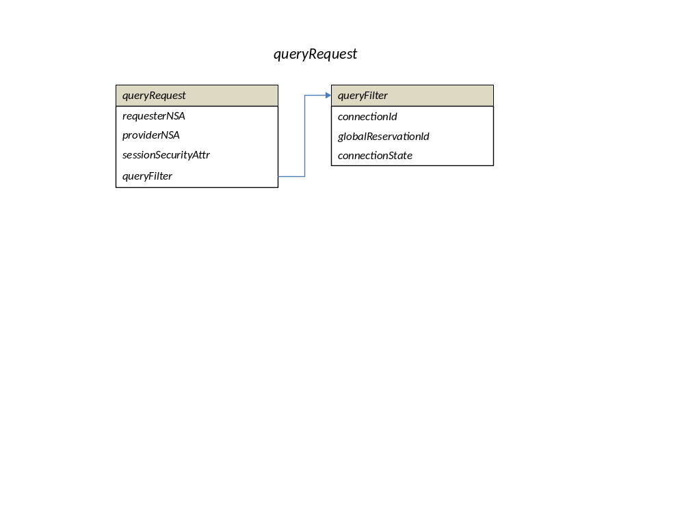
Figure 10: queryRequest

In the case of a successful completion of the query request the queryConfirm response is returned with the following attributes: requesterNSA, providerNSA, globalReservationId, description, connectionId, serviceParameters, connectionState.
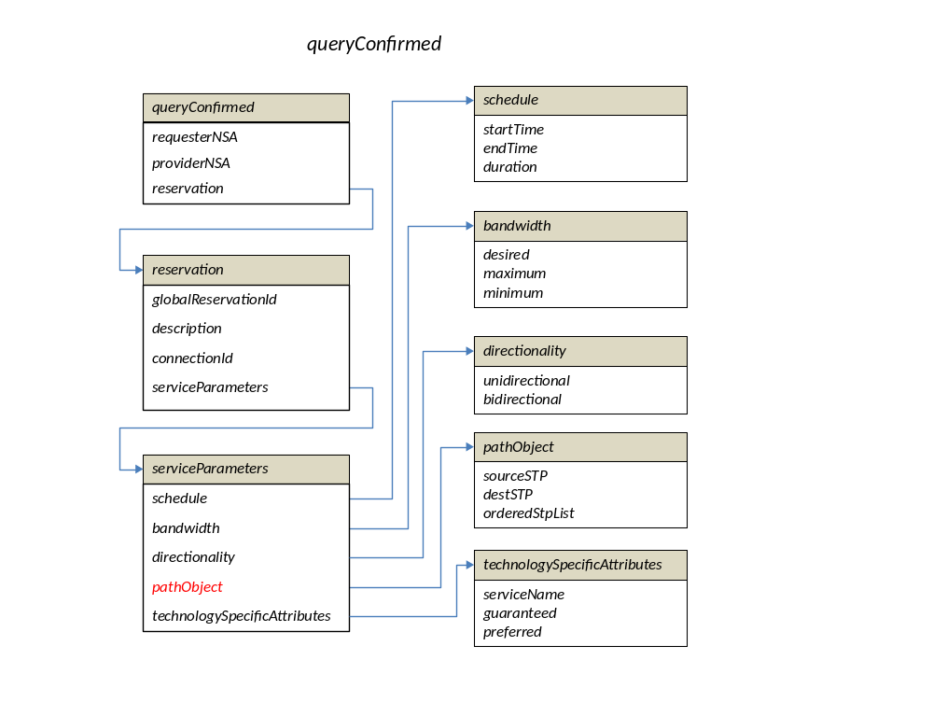
Figure 11: queryConfirmed

In the case of a failed completion of the query request the queryFailed response is returned with the following attributes: requesterNSA, providerNSA, globalReservationId, connectionId, connectionState, serviceException.

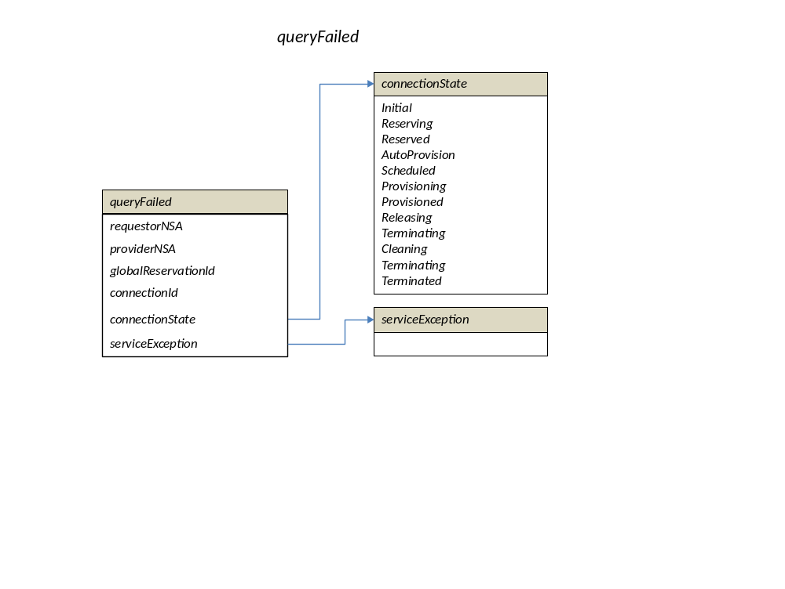
Figure 12: queryFailed

Connections: Transport and Service planes
The NSI Connection Service uses a simple abstracted representation of a Connection. This NSI Connection describes a conduit through which information is delivered from an ingress point to the egress point. While the model supports a uni-directional model of a connection, only point to point bidirectional symmetric Connections are supported in NSI version 1.0.

As illustrated in Figure 13, the Connection consists of three basic components: an ingress point where user data enters the connection, a transport section that carries the data across the network, and an egress point where user data exits the connection. These ingress and egress points are called Service Termination Points (STPs). This technology agnostic model of a Connection allows the NSI protocol to function with many different types of transport technologies.

The NSI CS protocol is an inter-network protocol, that is it allows Connections to be built across multiple providers. The NSI CS version 1.0 stipulates a somewhat limited yet highly functional set of abstracted topology constructs. The NSI topology consists of STPs, SDPs and Networks. Networks are groups of STPs reachable from a single common NSA across which connections can be constructed - see Figure 13. The semantics of the NSI Network and STPs assume that any two STP within a particular NSI Network are able to be connected. Implied is the requirement that NRMs must be able to build local connections between between all STPs in each Network that are advertised as part of a single Network.

Connections within a Network are intra-domain functions, and the technology details of how two STPs are actually connected is up to the local NRM and not a concern of the NSI protocols.

Two NSI Networks are connect to one another at a shared point known as an SDP. An SDP is a grouping of two adjacent STPs belonging to different Networks. A complete Connection can be built up by concatenating individual connections at SDPs.

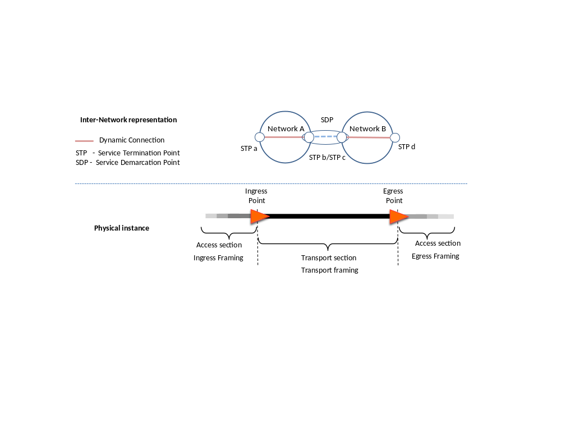
Figure 13: Inter-Network representation of a Connection

SDPs are a grouping of a pairs of STPs. Once instantiated, an STP may have properties such as a framing, bandwidth and a VLAN id. Some of these properties may reflect the requirements specified in the Service Definition. Labeling (cf. fiber id, wavelength, VLAN id) and aggregation (cf. combining multiple switch ports) can be modeled as a property of an STP.

The job of the physical instance of the Connection is to transport the user data (the “payload data”) across each section of the network inside a framing protocol. The framing protocol provides the necessary timing, control, and data integrity functions required to move the payload from node to node through the network. It is important to distinguish between a) the access framing protocols, b) the transport framing protocols, and c) the user payload data carried inside each of these protocols.

It is the user payload data stream that is preserved from ingress to egress in a Connection.

The transport framing can be any framing protocol as long as the end-to-end preservation requirement is honored. In fact, the only constraints on the transport framing is that the transport section be able to adapt the ingress payload data to each of the successive transport protocols that may be used along the path and ultimately be able to adapt the user payload to the egress framing at the egress point. While specification of the connection end points, access framing, and other parameters associated with a connection are defined by the connection requester (or implicitly by the service definition), the choice of the transport protocol and associated transport path parameters are explicitly delegated to the network service provider in order to allow the provider the greatest latitude in finding a valid, available, and optimal path for the connection request.

STPs and path objects

STP syntax
STPs are described using a tuple: networked: localId
networkId - An abstract reference to a network containing the STP.
localId - A locally unique identifier for the STP within the target network.

*** further syntax details to go here***

Under-specified STPs
**** text on under-specified STPs vs. fully qualified STPs.

Path Object
The Path Object (or Path) describes a route through the topology. When present in a Connection Request, the Path specifies an ordered set of Service Termination Points (STPs) that the connection must transit, and in the order the connection must transit them. Within a Connection Request, the Path Object, at a minimum, must specify the ingress and egress STPs for the Connection. Additional intermediate transit points may be included in the Path Object, and when present, they are considered a required constraint on the Connection’s route and must be honored.

The syntax for a paths is as follows:
pathObject - the source and destination endpoints of the service.
sourceSTP - Source STP of the service and techSpecAttrs
destSTP - Destination STP of the service and techSpecAttrs
orderedStpList - Hop-by-hop ordered list of STP from sourceSTP to destSTP.

pathObject == [sourceSTP, destSTP, orderedStpList]

Where:
orderedStpList == [ordered list of STPs]

Next, chain and tree examples are presented to show how a simple connection path can be described. The difference in the description is how the authorization is grouped in the path description.

Path object example – NSA chain

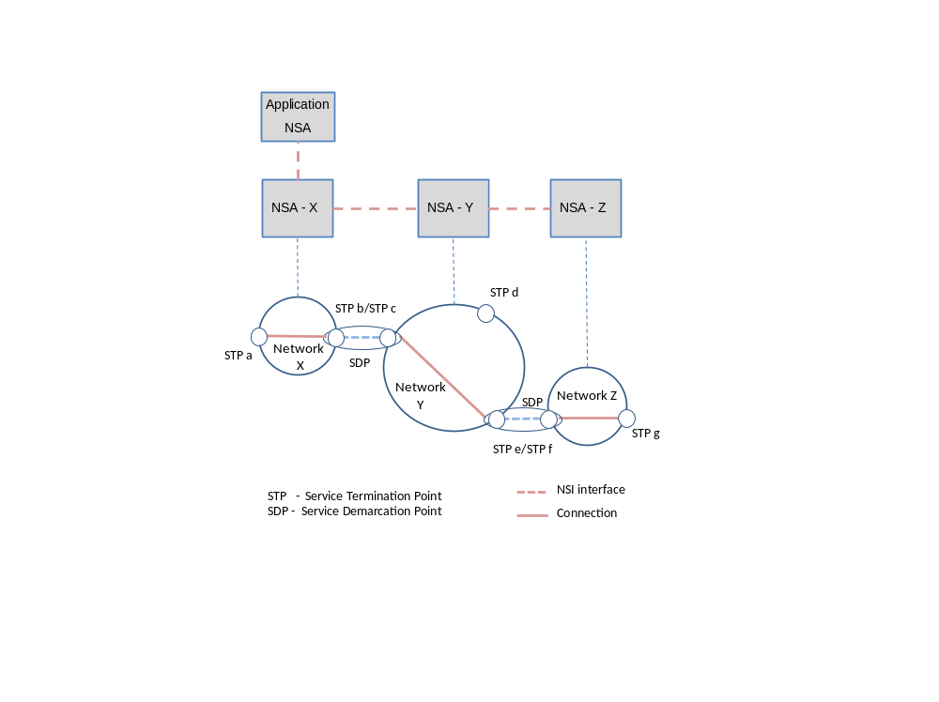

Figure 14: Example of connection managed by a NSA chain

In this example there is an Inter-Network Topology consisting of 3 networks, one per NSA. Each Network is described as a set of edge points on a network.

For this example the topology would look like this:

Network X: X:a X:b
Network Y: Y:c, Y:d, Y:e
Network Z: Z:f, Z:g

In this example, the NSAs are connected as a chain:
NSA-X(Requester) to NSA-Y(Provider), NSA-Y(Requester), to NSA-Z(Provider)

Assuming a request comes from the Application-NSA to NSA-X to reserve a connection X:a to Z:g, then NSA-X will look in the topology and determine that to make this Connection, NSA-X will reserve a local connection from X:a to Xb, and then NSA-X must forward a request for the remainder of the connection to NSA-Y: Y:C to Z:g

NSA-Y gets this request and reserves a connection between Y:c and Y:e and requests a reservation from NSA-Z for a connection Z:f to Z:g.

Path object example – NSA tree

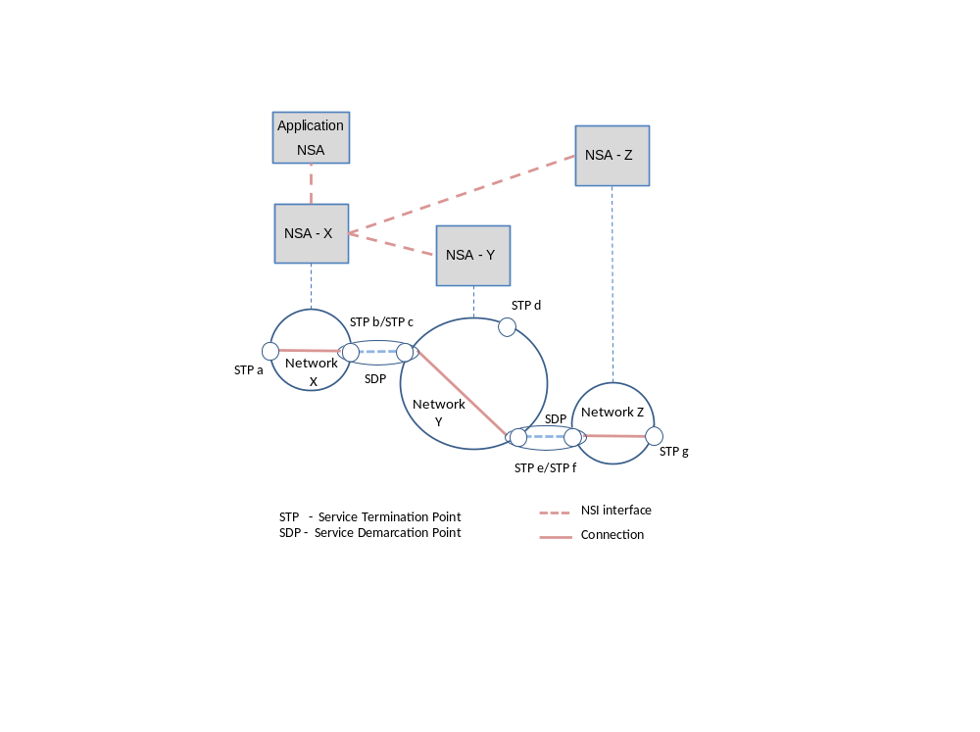
Figure 15: Example of a connection managed by a NSA tree

The topology remains the same as for the previous example:

Network X: X:a X:b
Network Y: Y:c, Y:d, Y:e
Network Z: Z:f, Z:g

In this example, the NSAs are connected as a tree:
NSA-X(Requester) to NSA-Y(Provider) and
NSA-X(Requester) to NSA-Z(Provider)

Assuming a request comes from the Application-NSA to NSA-X to reserve a connection X:a to Z:g, then NSA-X will look in the topology and determine that to make this connection, a connection request is required locally between X:a and X:b. Next NSA-X must forward two requests:
- To NSA-Y: Y:c to Y:e
- To NSA-Z: Z:f to Z:g

Inter-domain pathfinding
There are two levels of pathfinding related to the NSI architecture: the inter-domain pathfinding which is concerned with choosing a path across the global topology of Networks, and the intra-domain pathfinding concerned with the transport resources within the Network. NSI is concerned only with inter-Network pathfinding.

Inter-Network Connections extend across multiple networks; they are constructed by concatenating connections built across the individual networks. This is done by choosing appropriate STPs such that the egress STP of one connection corresponds directly with the ingress STP of the successive connection.

Both the Tree and Chain model reduce pathfinding to a constraint-based search over a topology to build a k-preferred path tree. The method, tree or chain, used to process a request is made exclusively in the requester NSA. No path finding algorithms (e.g. PCE or OSPF-TE) are mandated by NSI.

Authentication and Authorization

Security Requirements
The basic security requirements of any trusted, distributed service are: 1. The requestor and provider can be mutually authenticated: 2. The messages between them cannot be secretly tampered with (message integrity), 3. The provider should be able to get enough trusted information about the requester to satisfy its authorization requirements.

Message Security
Message integrity and authentication should be provided by the transport protocol over which the NSI messages are sent. Some examples of underlying secure protocols are: a VPN, Transport Layer Security (TLS), or SOAP with digitally signed messages. The choice of this protocol is not included in this specification, but should be addressed in a Security Profile (see the NSI CSv1 Security document for an example) .

Authorization
Authorization of resource use may be based on bilateral trust agreements between an RA and a PA. In addition, the NSI connection protocol provides a means of carrying identifying information on which authorization can be based. All NSI messages contain securityAttr objects associated with the requesterNSA and the providerNSA. The securityAttr object is left opaque in the schema to facilitate various types of authorization schemes. One model that can be supported is to provide a set of mutually agreed upon attributes for the requester, The NSI CSv1 document specifies a schema for an securityAttr that contains set of defined attributes that can apply to the RA or to the user who originated the request.

Service Definitions for Connection Services
A Service Definition describes, in very formal and declarative terms, the service being offered by a service provider to the consumers of that service. The Service Definition is a mechanism to capture both similarities and differences between service offerings of various network providers.

The Service Definition (SD) is a machine readable textual document that identifies each attribute of the service and the range of values that are allowed for each attribute within that service. The Service Definition consists of an XML file consisting of a serviceName and a set of serviceAttributes that must be defined in order to fully specify a service instance.

In this respect, the SD serves as a template for the reservationRequest primitive. The Service Definition (specified by the Provider Agent) and the Service Request (specified by the Requesting Agent) relate to each other in the following manner:
- Each service request must specify which service offering - i.e. the Service Definition, it desires.
- The Service Request must contain the desired values for each service attribute defined in the Service Definition.
- If the Service Request does not explicitly specify a value for a service attribute found in the Service Definition, then that attribute will take a default value as specified in the Service Definition.
- A service attribute that has no default value in the Service Defintion must be specified explicitly in the Service Request. Else, an error results and the request is rejected.

The following is a sample XML file defining a simple Ethernet Transport Service:

<?xml version="1.0" encoding="UTF-8"?>
<nsi:schema xmlns:nsi="file://local/Users/jerry/work/NORDUnet/OGF NSI-WG/nsi-SD-v1.0.xsd ">
<nsi:ServiceDefinition>
<nsi:ServiceName>Ethernet Transport Service</nsi:ServiceName>
<nsi:ServiceDesc>
Ethernet frames are transported from the ingress "Orig" NSI endpoint to
the egress "Dest" NSI endpoint.
</nsi:ServiceDesc>
<nsi:ServiceAttributeList>
<nsi:Attribute>
<nsi:AttrName>Payload Bit Rate</nsi:AttrName>
<!-- Maximum transfered bits. Since the "payload" for the ETS
is the actual ethernet frame, the bit rate will include all frame
header information as well as the payload section of the frame.
-->
<nsi:AttrMin>0</nsi:AttrMin>
<nsi:AttrMax>10000000000</nsi:AttrMax>
<nsi:AttrStep>50000000</nsi:AttrStep>
<nsi:AttrDefault>50</nsi:AttrDefault>
</nsi:Attribute>
<nsi:Attribute>
<nsi:AttrName>Payload MTU</nsi:AttrName>
<!-- Maximum size of the user supplied frames in bytes.
Note: this is a policing function and does not imply that frames
exceeding this length will be segmented. This parameter is used to
select paths that can carry frames of the specified size - it does
not imply segmentation of frames exceeding this size.
-->
<nsi:AttrMin>1500</nsi:AttrMin>
<nsi:AttrMax>9280</nsi:AttrMax>
<nsi:AttrDefault>1500</nsi:AttrDefault>
</nsi:Attribute>
<nsi:Attribute>
<nsi:AttrName>Max Frame Error Rate</nsi:AttrName>
<!--
The Max Errored Frame Rate specifies the maximum number of
errored frames that are allowed within a properly functioning
service instance each second If this frame rate is exceeded,
an "error" is declared.
This attribute is specified as "n" where n:= 1x10^-(n).
Thus larger values indicate fewer errored frames (more reliable).
And so a user service request specifying a number less than the
Max Frame Error Rate is within allowable range.
Note: this service definition does not describe how the errored
frames are detected.
-->
<nsi:AttrType>Integer</nsi:AttrType>
<nsi:AttrMinVal>0</nsi:AttrMinVal>
<nsi:AttrMaxVal>10</nsi:AttrMaxVal>
<nsi:AttrDefault>8</nsi:AttrDefault>
</nsi:Attribute>
<nsi:Attribute>
<nsi:AttrName>StartTime</nsi:AttrName>
<!--
Default equal NOW.
-->
<attrType>DateTime</attrType>
<nsi:AttrDefault>Now</nsi:AttrDefault>
</nsi:Attribute>
<nsi:Attribute>
<nsi:AttrChoice>
<nsi:AttrName>EndTime</nsi:AttrName>
<nsi:AttrType>DateTime</nsi:AttrType>
</nsi:AttrChoice>
<nsi:AttrChoice>
<nsi:AttrName>Duration</nsi:AttrName>
<nsi:AttrType>Time</nsi:AttrType>
</nsi:AttrChoice>
</nsi:Attribute>
</nsi:ServiceAttributeList>
</nsi:ServiceDefinition>
</nsi:schema>

The SD provides a template for an NSA to consult to insure that all service attributes are fully and properly specified in the service request. Formally, a service request must fully specify all attributes associated with a service before the network can allocate the resources. The set of attributes that must be specified is the set of attributes defined in the SD. The SD defines which attributes must be explicitly specified by the requester (i.e. they have no default value specified in the SD), and which may be omitted by the requester (the SD specifies a default value for the attribute.)

The Service Definition simply states the [possible] attributes of a service instance. A conforming user Service Request may still be rejected if the necessary resources are not available.

Traditional models of circuit services and control planes adopt a single very tightly defined data plane technology, and then hard code the service attributes (signaling parameters) into the control plane protocols. Emerging multiprotocol services will need to leverage many data transport technologies and will need to recognize a wider array of service attributes. The NSA Framework describes an abstracted notion of a “Conenction”, and the the NSI Service Definition provides a mechanism for specifying service specific constraints or limits on that connection as realized in different networks. It is up to the NSA path finders and/or the NRM pathfinders to select a path that meets the Service Request and is consistent with the network Service Definitions along that path. This framework allows a single service plane protocol suite to present different services and different transport capabilities to the user. A different control plane protocol is not required for every service variant.

In the NSI inter-domain context, several network operators define a single common Service Definition (CSD) for a service that they all want to deploy. They can each then take that CSD back home and engineer it into their respective networks and be assured then that the services they deploy are consistent and inter-operable across their domains – thus substantially increasing inter-operability and reach of the end-to-end services.

A Common Service Definition is a sort of ideal service: ideally, all participating networks will conform fully to the CSD. But perhaps not all networks can meet the full range of the service attributes defined in the CSD. (for instance some aspects of a CSD may require forklift upgrades to meet the full capability.) The Service Definition mechanism allows networks to offer certain variations on the service without sacrificing interoperability. For instance, perhaps some networks can only offer 1500 byte MTU, while other may offer 9000 byte MTU. This difference is easily specified in the local Service Definitions associated with each network. The pathfinders can take this into account and the services remain compatible for Service Requests requiring conventional MTUs. Those characteristics that a network cannot meet can be adjusted in their local SD to insure that requesters know which aspects are inter-operable and which are not.

While a network can adjust the range of a service attribute, it cannot chose to omit the attribute altogether – it must provide all of the service attributes of a Common Service Definition to some degree in order to remain compatible. When two networks compare their service definitions, the intersection of the service attributes defines the interoperability range of the two services. I.e. the intersection defines the set of service requests that can be provisioned across both networks. The larger the common ranges, the more likely service requests will be compatible with both service offerings. It therefore behooves the service providers to maximize the degree to which service attributes meet or exceed the ranges specified in the CSD. Doing so provides broader more interoperable services.

Finally, within the context of the NSI Framework, processing of Service Definitions requires a certain enhanced sophistication on the part of the Network Service Agent. The NSA must be able to do two things: First, it must be able to find and parse the Service Definition and use it to qualify service requests, insuring that all request parameters are fully specified. Second, the NSA must then be able to intelligently relate those requested service parameters to the attributes of the resources that are available in the network to choose a candidate path.

The first step of qualifying the request to insure it lies within the service envelope is relatively easy.

The second step of relating the service characteristics to the available resources is more complex. For instance, if the Service Definition specifies a “Capacity” characteristic with a service range of 10 to 1000 Mbps (megabits per second), and a conforming request is received asking for 500 Mbps, then the NSA resource allocator must be able to intelligently search the topology database (the resources) for those path segments that have an available capacity of 500 Mbps, tentatively reserving resources and releasing them as potential path segments are pruned.

This process that compares the service definitions to the resource topology DB is a more advanced capability that requires more study and work before it can be mapped to NSA features. Fortunately, the NSI framework relegates much of this resource specific allocation to the NRMs, which simplifies the NSI layer considerably. Indeed, the NSI layer can do first stage coarse grained inter-domain path selection based solely on intersecting Service Definitions found along the path with the request profile, and then consulting the specific NRMs along the candidate path so constructed will perform the fine grained reservation.

In NSI CS v1.0, the Service Definitions are only used to qualify service requests.

NSI Service Definitions v1.0

NSI v1.0 uses the Service Definition to act as a template to fully specify a service request. The basic form of a Service Definition is:

<serviceDefinition>
<serviceNameDecl>
<serviceDesc>
<serviceAttributeList>
</serviceDefinition>

The Service Attibute list are of the general form:

<Attribute>
<AttrName>
<AttrValue>
</AttrName>

For NSI v1.0, the Service Definition will be encoded as an XML document conformant to an XML Schema Definition.

ServiceDefinition | Comprises the specifications that fully and completely define an NSI “Service”
ServiceName | A string that distinguishes the service described in this SD from other services that may also be offered in the same NSI network. The name can be any length and may contain any characters printing characters. The name string carries no encoded information within an NSI context. It is simply a string. special characters are explicitly disallowed. Multi-lingual service names may be supported
ServiceDesc | A textual description of the service, or alternatively a URN pointing to a file containing the textual description.
ServiceAttributeList | A list of attributes that fully specify the service being offered.
Table 3: attributes of service definition

Failures and exceptions

Service plane failures

NsiExceptionType Common NSI exception used the protocol Failed message.
messageId - Message identifier uniquely identifying each fault within the protocol.
text - Message text, with replacement variables marked with %#.
variables - Variables to substitute into text string above.

Transport plane failures
Failures in the transport plane can occur at anytime, however within the framework of the NSI architecture, there are two time windows in which a transport plane failure is significant:

- The time between the service reservation phase and provisioning phase (i.e. T_{ReservationCompleted} to T_{ProvisionStart}), and
- The time between the service provisioning phase and teardown phase (i.e T_{ProvisionCompleted} to T_{TeardownStart}).

Of course, the errors only need to be handled by the NSA if the transport resource errors affect the user service.

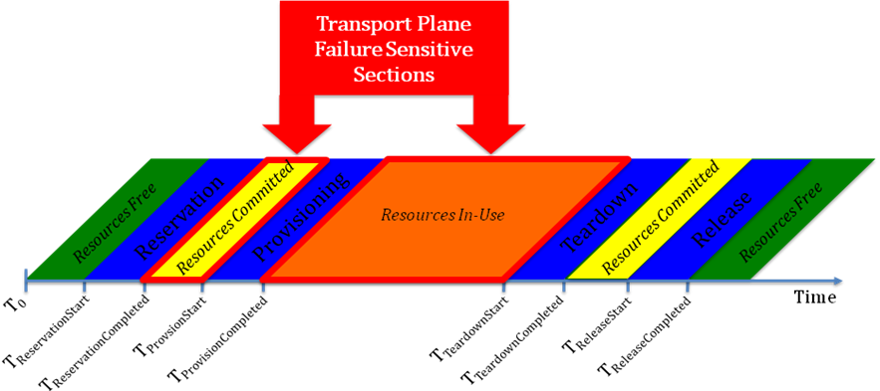 Figure 16: Local/Remote Failures

A few illustrative examples will help describe the kind of failure and recovery scenarios that have to be considered when building the state machine for the NSI protocol.

Transport failure during service reservation phase and provisioning phase : An element in the transport plane becomes unavailable due to a soft or hard failure causing a provisioning failure of a confirmed reservation, the reservation manager can handle this by either reserving an alternate path as long as it meets the requested service characteristics or terminating the reservation with notification. Domain policy and availability of resources will determine what recovery action is taken by that domain.

Transport failure during provisioning phase and teardown phase: In case a failure in the transport plane affects an active connection requested in the service plane, the first recovery mechanisms will be triggered by the protection mechanisms provisioned with the service. If the connection service is unprotected, then the failure notification will be sent to the Domain’s NSA. At that point, NSA will take appropriate action based on service and user policies by either re-routing the connection within the domain or tearing down the service with notifications to other domains involved.

Contributors
Chin Guok, ESNET
Radek Krzywania, PSNC
Tomohiro Kudoh, AIST
John MacAuley, Surfnet
Takahiro Miyamoto, KDDI R&D Laboratories
Inder Monga, ESnet
Guy Roberts, DANTE
Jerry Sobieski, NORDUNET

Glossary

Connection
A Connection is a conduit that transparently moves user information between STPs across a Network. A Connection has a set of properties (for instance, capacity, or authorization, or start time). These properties, and their allowed range of values, are defined by a Service Definition. A Connection instance on the Transport Plane is identified by a Connection Identifier exchanged on the Service Plane. Connections are unidirectional.

Connection Service
A Connection Service is a service that allows a Requester NSA to request and manage a Connection from a Provider NSA

Connection Service Protocol
A Connection Service Protocol is the protocol that describes the messages and associated attributes that are exchanged between RA and PA.

Control and Management Planes
The Control Plane and/or Management Plane are not defined in this document, but follow common usage.

Edge Point
A network resource that resides at the boundary of an intra-network topology, this may include for example a connector on a distribution frame, a port on an Ethernet switch, or a connector at the end of a fibre.

Inter-Network Topology
This is a topological description of a set of Networks and their transfer functions, and the connectivity between Networks.

Network
A Network is an Inter-Network topology object that describes a set of STPs with a Transfer Function between STPs.

Network Resource Manager (NRM)
The Network Resource Manager owns a set of transport resources and has ultimate responsibility for authorizing and managing the use of these resources. Each NRM is always associated with a single NSA.

Network Services
Network Services are the services offered by an NSA. Each NSA will support one or more Network Services.

Network Service Agent (NSA)
The Network Service Agent is a concrete piece of software that sends and receives NSI Messages. The NSA includes a set of capabilities that allow Network Services to be delivered.

Network Service Interface (NSI)
The NSI is the interface between Requester NSAs and Provider NSAs. The NSI defines a set of interactions or transactions between these NSAs to realize a Network Service.

Network Services Framework (NSF)
The Network Services framework describes a NSI message based platform capable of supporting a range of Network Services.

NSI Message
A NSI Message is a structured unit of data sent between a Requester NSA and a Provider NSA.

Requester/ Provider NSA
An NSA acts in one of two possible roles relative to a particular instance of an NSI. When an NSA requests a service, it is called a Requester NSA. When an NSA realizes a service, it is called a Provider NSA. A particular NSA may act in different roles at different interfaces.

RA/PA
Requester NSA/ Provider NSA

Service Definition
The Service Definition consists of a set of attributes that formally and explicitly define the complete scope of a service offering. Each provider defines its service with an SD, each request identifies requirements in terms of SD attributes, and each Connection has an associated Service Definition instance.

Service Demarcation Point (SDP)
Service Demarcation Points (STPs) identify a grouping of two Edge Points at the boundary between two Networks.

Service Termination Point (STP)
Service Termination Points (STPs) identify the Edge Points of a Network in the intra-network topology.

Service Plane
The Service Plane is a plane in which services are requested and managed; these services include the Network Service. The Service Plane contains a set of Network Service Agents communicating using Network Service Interfaces.

Transport Plane
The Transport Plane contains is the set of transport equipment and associated resources that carry user data through the network.

Intellectual Property Statement

The OGF takes no position regarding the validity or scope of any intellectual property or other rights that might be claimed to pertain to the implementation or use of the technology described in this document or the extent to which any license under such rights might or might not be available; neither does it represent that it has made any effort to identify any such rights. Copies of claims of rights made available for publication and any assurances of licenses to be made available, or the result of an attempt made to obtain a general license or permission for the use of such proprietary rights by implementers or users of this specification can be obtained from the OGF Secretariat.

The OGF invites any interested party to bring to its attention any copyrights, patents or patent applications, or other proprietary rights which may cover technology that may be required to practice this recommendation. Please address the information to the OGF Executive Director.

Disclaimer
This document and the information contained herein is provided on an “As Is” basis and the OGF disclaims all warranties, express or implied, including but not limited to any warranty that the use of the information herein will not infringe any rights or any implied warranties of merchantability or fitness for a particular purpose.

Full Copyright Notice

Copyright (C) Open Grid Forum (2008-2010). All Rights Reserved.

This document and translations of it may be copied and furnished to others, and derivative works that comment on or otherwise explain it or assist in its implementation may be prepared, copied, published and distributed, in whole or in part, without restriction of any kind, provided that the above copyright notice and this paragraph are included on all such copies and derivative works. However, this document itself may not be modified in any way, such as by removing the copyright notice or references to the OGF or other organizations, except as needed for the purpose of developing Grid Recommendations in which case the procedures for copyrights defined in the OGF Document process must be followed, or as required to translate it into languages other than English.

The limited permissions granted above are perpetual and will not be revoked by the OGF or its successors or assignees.

References
- OGF GFD.173: Network Service Framework
- IETF RFC 5905, Network Time Protocol Version 4: Protocol and Algorithms Specification
- IETF RFC 4122, A Universally Unique IDdentifier (UUID) URN Namespace
- IETF RFC 4655, "A Path Computation Element (PCE)-Based Architecture"
- ISO 8601:2000 “Data elements and interchange formats — Information interchange — Representation of dates and times” or xsd dateTime

Outstanding issues
- The authentication method needs separate method for WSDL implementation, this may require changes to the statemachine
- In general the requester and provider parts of the WSDL should be split so that these can be compiled separately
- What is the suitable location for the pathObject? In the serviceParameters or the reservation?

